
____________________________________________________________________________________
FOR IMMEDIATE RELEASE

NEWS R ELEAS E
CFAL Donates Over 100 Workbooks to Uriah McPhee Primary School

Nassau, Bahamas — October 10, 2025: Standing before hundreds of smartly dressed and well-mannered students, executives and managers of Colina Financial Advisors Ltd. (CFAL) shared words of encouragement before presenting more than 100 phonics and mathematics workbooks to the third-grade students of Uriah McPhee Primary School.
The donation, presented during the school’s general assembly, forms part of CFAL’s ongoing commitment to improving the lives of those in its surrounding community through education and empowerment.
“The executive management and staff of our company are passionate about educating young Bahamians and giving them the tools they need to thrive,” said Paige McCartney, Marketing Coordinator at CFAL. “We believe that learning is the foundation of opportunity, and we’re proud to support students right here in our neighbourhood.”
The idea for the book donation came from Pamela Ferguson, CFAL’s Vice President of Investments, who wanted to make a meaningful and lasting contribution to local students.
“We often talk about investing for the future — and there’s no better investment than in our children,” said Ferguson. “By providing these workbooks, we hope to help students build confidence in reading and math as they prepare for next year’s GLAT exams.”
Third grade teacher Shareka Murphy said the donation goes beyond the classroom.
“Some of our parents are unable to afford textbooks, so the students would have to copy or share. So, this donation means they can use these books and we don’t have to worry about a child missing a grade because she wasn’t able to do her homework on time or because their parents are having a hard time,” she said.
Uriah McPhee Primary School boasts being the top performer for third graders in the district in the annual Grade Level Assessment Test (GLAT) examinations.
CFAL has also pledged to provide the students with the necessary workbooks needed to assist them in preparing for the exams next year.
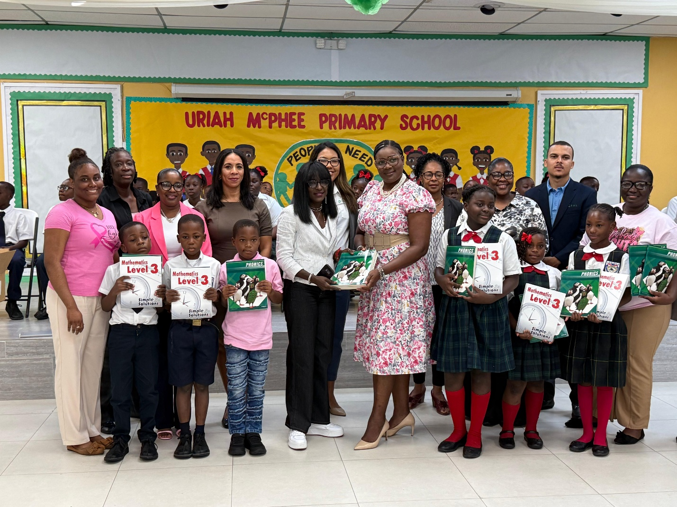
Caption: Executives and managers from Colina Financial Advisors Limited (CFAL) pose with teachers, administrators and third grade students at Urian McPhee Primary School.
***
Colina Financial Advisors Ltd. (CFAL), established in 1997, is a leading provider of investment management, pension administration, retirement planning, corporate advisory, saving, and wealth management solutions in The Bahamas. The award-winning CFAL team has helped individuals and institutional investors secure their financial futures through research, innovation, expertise, and integrity. CFAL also offers free financial advice through the CFAL Talks podcast, which is available at cfal.com and on Apple and Google Podcasts. In 2022, CFAL celebrated 25 years of growing wealth for generations of Bahamians. Learn more about our client-centric approach at www.cfal.com.

